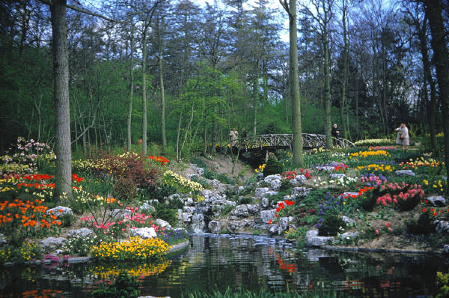

7:00 Eugene Mattie - Cowings Cove

7:30 Citizen Comments

7:35 Paul Foulsham – Main Street Paving Discussion

8:00 Pat Anderson – Precinct Map

8:15 Conservation Commission

New Business

- Car Wash Request

Road Openings

Announcements

Executive Session – Collective Bargaining, Pending Litigation

